St Marys Soccer Club

COACH & MANAGER
HAND BOOK
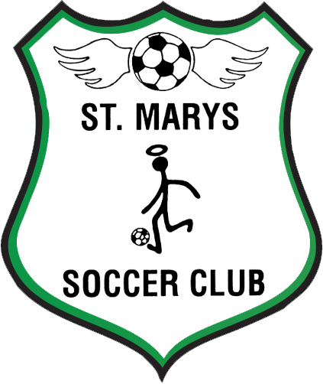

2021 SEASON

Welcome to St Marys Soccer Club 2021
This is our handbook for all coach and managers, please use this to your advantage and take it with you to ALL games. As much information as possible has been included for your benefit. If you need any further assistance with anything please don't hesitate to ask a committee member or contact Bek - secretary@stmaryssoccer.com.au
2021 Committee -

- Neil Graham - President/
- Kevin Zoutendijk – Vice-President/ MPIO/Public Officer
- Bek Borg - Secretary
- Jaz Hodge - Treasurer
- Satya Naicker – Competition Secretary
- Maria Feleks - Registrar
- Aiden Branik – Webmaster & Communications Officer
- Maryanne Moore – Social Secretary & Canteen Manager
- Tim Denham – Sports Manager
- Rebecca Pressick – Assistant Secretary
- Brendan Malzard – Assistant Social secretary
- Danial Branik – Committee Person
- Natalia Levia – Committee Person
- Wayne Mallia – Committee Person
- Wayne McKenzie – Committee Person

CONTACTING COMMITTEE
Contacting committee members is something that needs to be addressed with common sense and respect. Preferably coach/managers contacting us in regard to most matters within this booklet is a good idea. Committee positions are voluntary, and we have 25 teams to look after. Please seek us out for help in anything regarding your teams/players/equipment and we will assist you the best we can, if not, we can point you to the best person. Please keep phone calls/texts to a decent time.

CONTACTING NEPEAN
The protocol for contacting Nepean (NFA), is that it needs to come through the club. All correspondence needs to be in a written format, handed to our secretary Bek Borg 0419485876 to be tabled at the next committee meeting and forwarded on to NFA. If you ring NFA directly without informing us, we will be held responsible for your actions, so please respect the protocol. Choosing to ignore this protocol, is considered a breach of the clubs Code of Conduct and may result in you having to appear before the committee. We will endeavour to seek appropriate action ASAP to help and or solve any conflict that arises.

FACEBOOK
This is used mostly for posting Club updates/reminders/events/ information/wet weather cancellations/park closures. We will try to keep it up to date ASAP.
Like us on Facebook – St Marys Soccer Club

2021 YEARBOOK/REPORTS
Every year St Marys Soccer Club produce a yearbook, which has evolved to be a great publication, and a fantastic record of who was involved with the club over the years. We rely on reports about your teams to add to the yearbook, it does not have to be a literary triumph, however we ask that something, not too monumental be written about each team. All Coach/managers do it differently some choose to write about each player, some about the team as a whole, it doesn't matter as longs as a little something is written. These reports will be required around August, so beware that our Webmaster & Communications Officer Aiden Branik will be calling on you for these.
COACHING PHILOSOPHY
The aim of coaching at St Marys Soccer Club is to create an environment where every player can have fun, flourish, develop skills and fulfill their potential.

We recognize, every player will have different abilities, learning styles and aspirations.

Coaching at St Marys Soccer Club will be:
Positive
Instructive
Encouraging

We seek to develop members to be:
- Hard working - Praising Players because they work hard will see them seek to work harder.
- Brave - Encouraging Players to take risks will see them try new skills and not be afraid to use them on the field.
- Good team players - This can cover everything from communicating with one another to standing up for each other.
- Players with a passion for and enjoyment of the game.

Players should receive equal playing time and be given equal opportunity to play different positions on the field (particularly when they are young). Coaches are encouraged not to pigeonhole players into one position, this means, we will produce more versatile players with a better, more rounded skillset. This is particularly pertinent for goalkeepers. Nowadays they are required to be skilful with their feet, able to pass the ball and even dribble it. Coaches should be prepared for teams to lose in the short term with a view to long term improvement

To support our coaching Philosophy St Marys Soccer Club commits to:

- Review all Coaching Applicants, during our registration period, to ensure all Coaches will model this Philosophy, placing development ahead of winning.
- Ensure all Coaches have a Working with Children’s Check prior to commencing the first training session.
- Provide necessary training for all Coaches, including covering the associated financial costs. Grassroots Football Certificate for 5-9yo, Skill Training Certificate for 9-13yo, Game Training Certificate for 13-17yo, Senior Coaching Certificate for 17+ yo, Goalkeeping Certificate.
- Provide all necessary equipment for Coaches to undertake training and game day activities.

POLICIES
St Marys Soccer Club are busy behind the scenes to bring our Club up to date and in line with FFA/FNSW and NFA policies. Hopefully, a series of these polices/rules/regulations will be rolled out during the season. All will eventually be available 0nline at www.stmaryssoccerclub.

MINI ROOS 2021 -Small Sided Football
Where having fun, making friends & learning our great game are the main ingredients.
For those teams from Under 5 to Under 11 there will be a full version of Mini Roos regulations contained in your booklets. Helpful information can also be found at the Mini Roos website www.playfootball.com.au/miniroos
A separate Electronic Match Sheet guide will be emailed and is available with this handbook

Under 11 even though they are classified as Mini Roos, they are being prepared for the future of Competitive Football. Under 11's will submit scores, however won't have tables generated for them.

COMPETITION TEAMS 2021
Competition teams range from Under 12 to All Age including O35s
You will find information in this booklet in regard to running Competition Teams, so that you have access to the rules and regulations at hand. The full competition regulations for 2021 will be emailed to you and can be found on our website and Nepean's website, ignorance of these rules is not an excuse.
A separate Electronic Match Sheet guide will be emailed and is available with this handbook

WEBSITES YOU WILL NEED:
www.stmaryssoccer.com.au - for general club info and links
www.nepeanfootball.com.au - for looking up the draw/tables/scores/rules/regulations/links
www. playfootball.com.au/miniroos - for useful hints and tips on mini roos www.footballnsw.com.au - assorted info, coaching resources', rules
www.playfootball.com.au - registration issues/your accounts/changing details

FUNDRAISING/SPONSORSHIP
If you know of any fundraising or sponsorship opportunities that would benefit our club please contact our President Neil Graham 0419692885
Any assistance would be appreciated to encourage member participation in fund-raising ventures. After all, it helps keep the costs down, which can only benefit all concerned.
PARENT HELPERS
- 2 Parent Helpers per team are required to assist the committee at home games (this works out to be possibly two games per parent per season)
- They are only required for 30 mins prior to their child’s game – We promise they will not miss their child’s game
- No helpers are required after the game
- We encourage all parents to volunteer, it needs to be fair
- Parent helpers are to be a parent not the coach or manager. You are already volunteering your time and will be busy getting the teams ready to play

COVID Safe Protocols
To help ensure that the appropriate safeguards are in place when participating, all players, parents, officials and spectators (where applicable) are required to adhere to the following:

- Do not attend training or games if you are feeling unwell or have any cold or flu like symptoms, even a runny nose or scratchy throat. Self-isolate immediately and get tested.
- Wash and/or sanitize hands before and after attending all training and games
- Players arrive dressed and ready to train or play
- When arriving at training and games please check in using the QR code provided
- Players must comply with the 1.5m social distancing rule at all times (except during games)
- No shaking hands, high fives or hugging other players, match officials, team officials or spectators
- No player walkouts prior to matches
- No player huddles or post-match huddle celebrations
- Avoid carpooling as this is considered “close contact” and increases the risk of transmission
- Do not share drink bottles
- Do not share containers of food, including oranges. Players should bring their own food and snacks.
- Spectators must observe the 1.5m social distancing rule at all times unless from the same household
- Players and spectators must not socialise or assemble in groups before, during or after training or games
- Once training and games are finished, leave the venue as soon as possible
- Get tested for COVID-19 if you feel unwell or develop cold or flu like symptoms
- Regularly check the NSW Health Covid-19 Case locations and health advices.
- Check for updates on the Football NSW Covid-19 Information webpage
- Avoid bringing anyone who may be at high or increased risk of illness
- Do not bring anyone with you to training or games that has attended any NSW Covid-19 case location listed on the NSW Health website or been in contact with a positive case of Covid-19 within a 2 week period or who has cold or flu like symptoms. They should also immediately self-isolate and get tested.

Jamie Dettmer Junior Club Person of the Year Award
Jamie Dettmer was a life member and long standing coach and committee member of St Marys Soccer Club who sadly passed away in late-2020. Jamie in particular was heavily involved in promoting junior and female football at our club.
The club, in consultation with Jamie’s family has decided to introduce a new award in 2021, recognising a junior club member and their contribution to the club. This is not an award based on the best player in the team, but rather the player who best represents and supports the club’s values.
Towards the end of the season, the coach and manager of each team will be invited to nominate a player from their team for this award, giving brief reasons why that player has been nominated. The management committee together with representatives of Jamie’s family will then select a recipient of that award.

Below are the criteria that coaches and managers are asked to take into account:-
- Demonstrating leadership skills, encouraging and supporting players in the team;
- Being reliable, attending training and games, on time and ready to go with a soccer ball and drink bottle;
- Playing the game in the right spirit, including demonstrating respect for the referee, coaches, managers, supporters as well as the opposition;
- Demonstrating sportsmanship;
- Assisting the coach manager and club with tasks, this may include things such as cleaning up witches hats fields and rubbish during or after training and games;
- Any other matters that the coach or manager may consider

GENERAL INFORMATION FOR ALL TEAMS
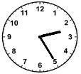

Duration of Matches
U5 & U7 - up to 30 mins
U8 & U9 - 40 mins
U10, U11, U12 - 50 mins
U13 & U14 - 60 mins
U15 & U16 - 70 mins
U17 - 80 mins
U18 & All Age - 90 mins

- Half time break will be approx. 5 mins
- If the match official shortens any game, both halves of the game must be the same length of time, not including time added on for injuries
- The referee shall be the sole judge of time for all games.

Ball Sizes
U5 to U9 Size 3
U10 to U13 Size 4
U14 to All Age Size 5

TEAM KITS
Every team is issued with a full kit which comprises of the following items -
- A full set of playing jerseys - applicable to age and team requirements
- A set of ID vests - Coach - fluoro Yellow, Manager - Blue, Marshall - fluoro orange
- 1 match ball
- A set of team ID cards for all players, coach and manager

- The above equipment remains the property of St Marys Soccer Club so please try your best to look after this equipment and most importantly RETURN it.
- Any outstanding equipment after return date, will be invoiced to teams to cover costs.
- If you are missing any of these items please bring it to the attention of a committee member, ASAP
- Our Sports Manager Tim Denham 0410 495 824 can arrange any items or replacements your teams require.
- PLAYING SHIRTS MUST NOT BE WORN IN GENERAL PUBLIC AWAY FROM THE PLAYING FIELDS.
- For the 2021 season, due to COVID-19 restrictions all Jerseys and ID Vests are to be taken home each week to be washed by the individual. Jerseys are NOT to be shared between players. All Jerseys and ID VEST are to be returned to the coach/manager at the end of the season and then returned to the club.

COLD WATER WASH ONLY - DO NOT PUT IN CLOTHES DRYER - DO NOT ATTEMPT TO IRON
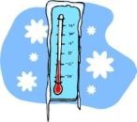

PLAYERS EQUIPMENT
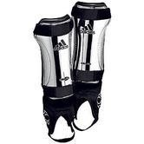
- All players are required to wear regulation shin-pads at all times during the game. Shin-pads must cover the majority of the leg between ankle and knee and a sock must cover the shin-pad.
- SHIN PADS MUST BE WORN AT EVERY TRAINING SESSION- this is an insurance requirement, players not wearing shin pads may make their insurance invalid

THE DRAW
- The 2021 Season draw will be released in 4 week blocks
- The draw will be distributed through several avenues. Our Competition Secretary will directly send it via WhatsApp, it will be available on our website www.stmaryssoccer.com.au and will be posted at the canteen each week.
- All competition draws can be checked on icompman – please see below for instructions on how to do this.
- Our Competition Secretary will forward any game change notification but some changes maybe last minute. Please check your fixtures every Friday before the games for any changes.

To access icompan
- Visit Nepean website www.nepeanfootball.com.au
- Click on the "competitions" button

- From the drop-down box click on “Fixtures”

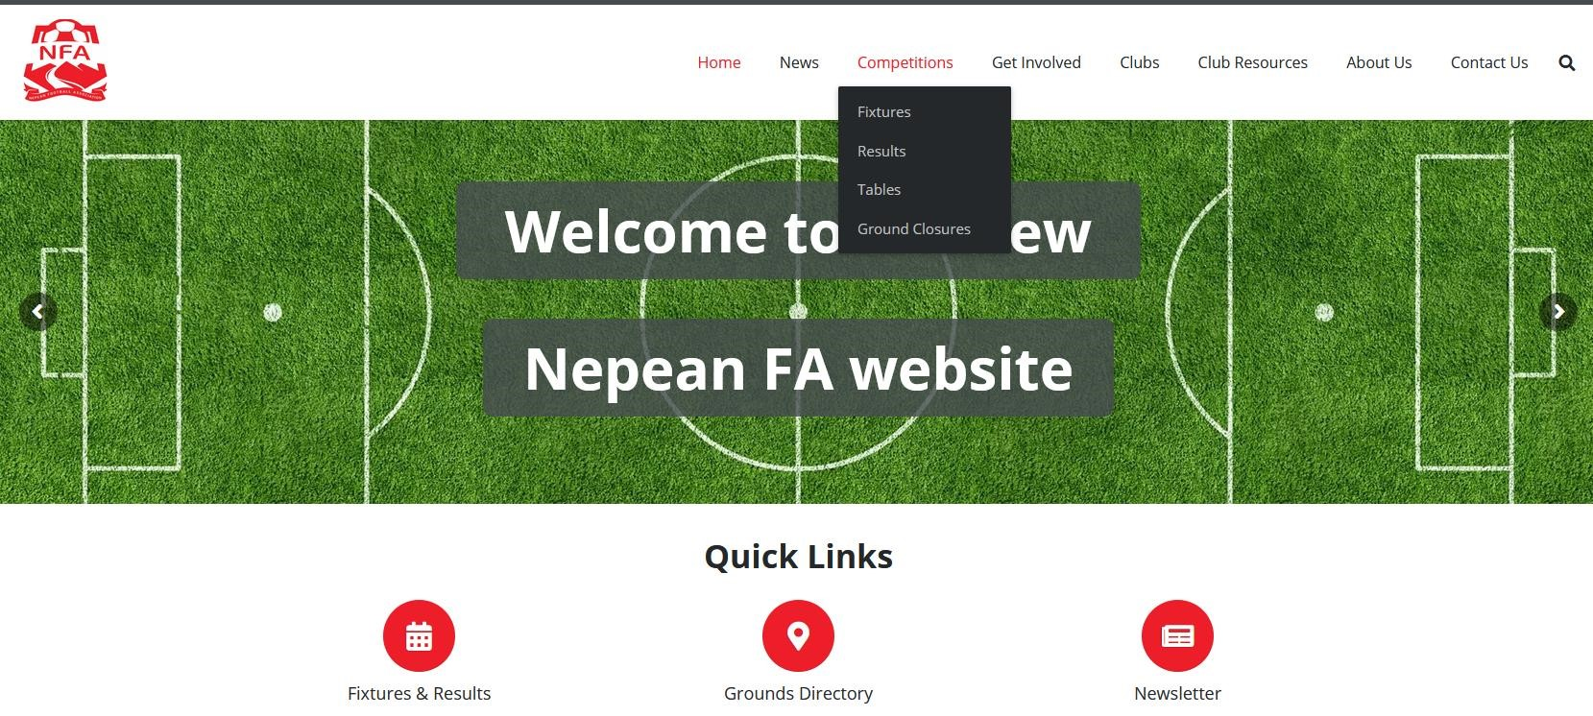

- Click on the appropriate filters by using the drop-down options of each search criteria. The info you are looking for should appear. HINT - always check the dates you have applied for are correct.

REQUESTING GAME CHANGES
An agreement needs to be reached between the 2 clubs involved, and a reasoning that considered genuine and not frivolous (A wedding/christening is all considered frivolous).
The request must be submitted at least 7 days prior to the original match schedule
A suitable venue and kick off time must be submitted and confirmed by NFA as available
WET WEATHER PROCEDURES
- ALWAYS ASSUME THE GAMES ARE STILL ON until you hear specifically from our Competition Secretary, via phone call or text.
- Just because some grounds are closed it DOES NOT mean your game has been cancelled. Nepean will engage their emergency regulations to be able to move games within 48hours. Games can be transferred to Neutral Fields
- Once you have been contacted re: wet weather cancellations, or game transfers please txt back with an acknowledgement - so we know you have received the information.
- Mini Roos may not be necessarily re-scheduled.
- Teams playing the longest distance away at the earliest times will be contacted first, then those closer to home will be next and so on.
- Training - When the fields are unsafe, they will be closed for training. A message will be posted in WhatsApp Group Chat by 4pm ONLY IF FFIELDS ARE CLOSED and again when they are reopened.
- It is the responsibility of the Coach and the Manager to notify their players. Parents should be encouraged to keep in contact with Coaches & Managers, not the Committee.
- Our Facebook page and website will be updated ASAP to keep members informed.

REFEREES: COMPETITION TEAMS
NRG referees being used for Nepean competition games once again.
Referee coverage will be notified to Coaches & Managers via WhatsApp either Thursday or Fridays
The procedure when no NRG referee is appointed or has not shown up is as follows:
- The team managers, or captains, of both teams shall agree to appoint a referee to control the game.
- First preference shall be given to any accredited referee who is available and willing to officiate. The accredited referee may have (and should declare) an affiliation with one of the two clubs involved in the fixture if an affiliation exists.
- Unofficial referees, if appointed to a match, must be suitably attired, carry a whistle, a time keeping device and a set of cards for use in the match. (see host club)
- No person that is currently under suspension from any football organisation, may referee a competition match as an official or unofficial referee.
- The referee’s details must be entered on the Electronic Match Sheet and indicate whether they are official referee or an unofficial referee. Official referees are to write their FFA registration number in the space provided.
- If an agreement between the two teams is still not reached after applying the above appointment hierarchy rules, the game will be dealt with in the same manner as an abandoned game. SEE ABANDONED GAME

GAME LEADERS: MINI ROOS U5-U11
We are continuing to develop our Game Leaders initiative from our junior ranks
Game Leaders are rostered on rotation for all Mini Roo’s games played at home
If anyone is interested in becoming a Game Leader please see Satya Naicker 0419948294
We EXPECT that our Game Leaders will all be treated with respect. They may not get every call correct, they are learning and giving back to their chosen sport, which we greatly admire.

TRAINING

Our fields will be open for training Tuesday, Wednesday, and Thursday,

All teams will be allocated a training day, time, and space for training.

Please remain within your allocation and remember that your actions impact on others

Committee members will be present for all training and the toilets will be opened.
- Training equipment will be available for use. Please collect from the container closest to the canteen and then return at the end of your training session. All equipment is to be wiped down after use.
- If you have any issues with Training - please contact our Sports Manager Tim Denham 0410 495 824
- If you will not be running training please let us know through WhatsApp

FIELD LIGHTS
Field lights will automatically turn on between 5-5:30pm and turn off by 9:15pm Tuesday, Wednesday & Thursday.
If for some reason the lights do not work, please contact our Sports Manager Tim Denham 0410 495 824

FIELD SET UP/PACK UP
- Field set up (nets, flags/cones) for all home games is the responsibility of the team allocated the first game of the day for that field, you will need to arrive earlier (at least 15mins) than usual, to put up the nets.
- Field pack up (nets, flags/cones) for all home games is the responsibility of the team allocated the last game of the day for that field. Please place the nets in the correct bin & return it to the container & store it in a tidy manner
- It is the responsibility of the Coach/Manager to check the draw to see if their team needs to put up or take down the nets.
Neutral Field Games When travelling to a neutral field game, please be aware, the hosting club may be opening or closing just for your game. We would ask that you lend a hand to set up or pack up, and don't forget to thank them upon leaving.

TEAM SHEETS
Competition teams- Please ONLY use if the Electronic Match Sheet does not work. If you are the home team at a neutral field, please pick up your team sheet from our fields before your game to take with you, just in case. For instructions on how to complete a Team Sheet - Please refer to the example at the end of this booklet.

Player IDs
Player ID sheets are to be taken to all games, to be used if the Electronic Match Sheet does not work.
If the Electronic Match Sheet isn’t working then - NO CARDS NO PLAY !
Please look after them, check they are with you before you get to the game, not once you are there!
If your opposition team does not have their ID cards available and present for checking, the Regulations provide the following outcomes:
1. If a team fails to produce their ID cards prior to the match:
- The offending team shall be deemed to have forfeited the match; and
- The opposing team shall be credited a Win on forfeit (result shall be recorded as a 3-0 win).
- When ID cards are not available prior to the match, teams are not permitted to play a game, either as a competition game or friendly. A fine may be imposed for non-compliance with this rule
- Notify our Competition Secretary Satya Naicker 0419948294 immediately if the opposition team fail to provide ID Cards.

FORFEITS
- Any team failing to play the match as scheduled shall be deemed to have forfeited the match
- A competition team must field at least 7 registered players at the commencement of any match. Failure to do so shall deem the team to have forfeited
- Any team forfeiting a game, the opposition shall be credited with a 3–0 win
- As soon as you become aware your team needs forfeit please notify our Competition Secretary Satya Naicker 0419948294
- Remember if you have 7 available players your team is advised to play. Check with lower grades, they may be able to help, as long as they have played their game first. Remember, you will need the permission of the upgraded players coach and their ID card.
- If a forfeit without notice occurs on game day , make sure you fill out the Electronic Team Sheet completely as if you were about to play the game and hand in as usual as it will show who caused the forfeit.
- Fines apply for forfeits and vary from comp to non-comp teams. Referees fees are payable regardless of the notice provided. Teams may be responsible for payment of any fines

ABANDON GAME
Is a game that was not played for the full duration of the match because it was ended early by a referee. NOTIFY our Competition Secretary Satya Naicker 0419948294 immediately if your game is abandoned
Penalties will apply if failure to report
Abandon Games can happen for the following reasons:
- Serious injury where the player requires medical attention and cannot be moved
- Field declared unsafe by referee due to inclement weather
- The number of players falling below 7 (comp games only)
- Poor behaviour of players/spectators/team officials
lights going out/sprinklers coming on during a night fixture
An abandon match report must be completed, online - www.nepeanfootball.com.au/competition-forms/ within 24hours of the match

PLAYER INJURIES
All injuries which occur at Training or Competition Games must be reported to our Secretary Bek Borg 0419485876 on the day that the injury occurs, so that a log of injuries can be maintained. Insurance Claims must be submitted within 21 days of the Injury.
A Player insurance claim form must be completed online www.nepeanfootball.com.au/competition-forms/

FIRST AID
We have a First aid kit and defibrillator available from the canteen, and ice packs kept in the freezer. Most of our committee members are first aid trained and can offer support

UPGRADING RULES
UPGRADING OF PLAYERS TO HIGHER DIVISION OR AGE GROUP
- The rules of upgrade are designed to allow teams to borrow players if there are shortages due to injury or absenteeism. They do not exist for coaches to continually borrow players from different teams to gain additional game time that deprives regular team members of their game time. The Association expects that existing team members receive game time before any player that is being upgraded.
- Players can be upgraded provided that the player fulfils their own team’s obligation and does not cause the team to forfeit through lack of players
- For any competition game, no more than three players, regardless of age or division, may be upgraded into a team. Except as permitted in 5.4.b.
- To be used as an upgraded player in a Final or Championship Tournament match a player must have played for the team they are upgrading to for at least 20% of that team’s matches during the regular season.
- If a team is re-graded to a different division and all associated results are made “void”, then any upgrades used by the team being re-graded shall also be deleted from the records and will not count towards the total number of upgrades used by a player. Player and team disciplinary records remain in force irrespective of upgrades and team re-grades.
- In instances where a match is abandoned, the up-grade of a player will remain on record and will count towards the upgrade tally of that player.
- A player may not be listed as upgraded while under suspension.
- From age group U13 and above, male and female players are not permitted to be upgraded between male and female competitions.

UPGRADING OF PLAYERS PARTICIPATING IN U12 TO U17 TEAMS
- A player may be upgraded to play in higher age group or division in the current season provided:-
  - The player does not play more than 2 years above the players age, ie. To play in a U14 team the player has to have turned or be turning the age of 12, regardless of the team the player has registered with
  - If a player is playing in the same or one age group above the team in which they are registered, they may only play in a higher division if playing in the same age group, or in an equal to or higher division if playing into a higher age group, eg Players in U12/3 team can play in a 12/2 and higher or 13/3 or 13/2 or higher team but not a 13/4 team,
  - If the player is upgraded two age groups above their team eg, U12 to U14 teams (subject to meeting the age requirement above) they will be permitted to play in any division.
- Players from non-competition age groups (U11 & younger) may only upgrade into competition age groups (U12 & above) a total of three (3) times. Upon the fourth and/or subsequent upgrade/s the resulting penalty will be a Loss of Points to the competition team using the upgraded player. It is the responsibility of each team to keep accurate records of upgrade usage in order to avoid penalties.
- For players in U11 and U12 mixed teams, male players are eligible to upgrade (subject to meeting the age requirement above) to mixed teams in the U12 age group and boys teams for older age groups. Female players are permitted to upgrade (subject to meeting the age requirement above) to teams in the U12 age group and female teams in older age groups playing in a female competition.
- Players from U16 teams to U17 teams (where an U17competition exists), who have attained the age of 16, may upgrade to any Intermediate Men’s or Women’s or all age division (male and female) within their club, regardless of the division of their original team (Example – An U17.1 player may upgrade to AM division 1 or division 5, but not into a female team).

UPGRADING OF PLAYERS PARTICIPATING IN ALL AGE TEAMS
- All Age Men’s & All Age Women’s teams (any division) can upgrade players, provided they have attained the age of 16, from lower division teams within their own club. The maximum number of players that can be upgraded for a game is three (3).
- Over 35 and Over 45 Men’s and Over 30 Women’s teams can upgrade players, provided they qualify for age criteria for those age groups, from lower division teams within their own club. The maximum number of players that can be upgraded for a game is five (5)
- For male players, teams in O45 competitions are considered to be in lower divisions than teams in O35 and AM competitions, while teams in O35 competitions are considered to be in a lower division than teams AM competitions. For female players, teams in O30 competitions are considered to be in a lower division than teams in AW competitions.
- Veteran players, who have attained the age of 40 years old, may be upgraded on an unlimited number of occasions to any team which is a higher division than the team they have been registered with.

FIELD LAYOUTS/TECHNICAL AREA
- Spectators are always required to remain behind the one (1) metre line, which runs parallel to the field of play
- The area behind the goals at each end of the field shall always be kept free of spectators
- A technical area is located on one side of the full-size playing field measuring 1m deep x 13m
- The technical area shall house the coach and manager and substitutes for the teams taking part in the match. No other person may occupy the technical area. No person is permitted to issue instructions from any other area
- The four (4) metre area between both technical areas shall remain spectator free and shall be used for player interchange only
- Fines can be issued by Nepean for breaches to the above

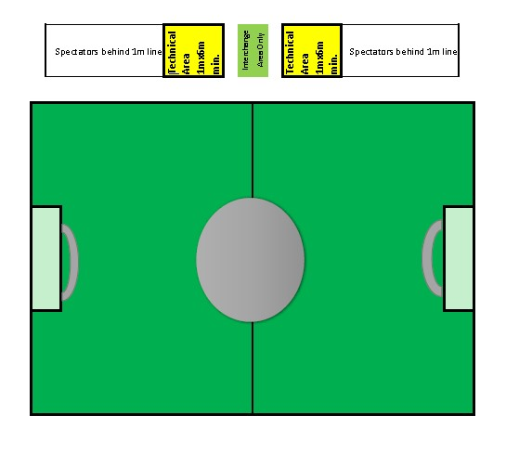

MARSHAL DUTIES
- At all matches, there shall be a minimum of two marshals, one marshal from each team, wearing an appropriate vest as purchased from the Association.
- The marshals shall introduce themselves to the referee before the commencement of the game.
- Marshals’ duties shall be to ensure that spectators, coaches and managers do not encroach the sidelines, or the pitch, and see that good order is maintained.
- Should any incidents arise out of a match that are for consideration by the Board, each marshal shall complete a written report into such incidents for the Board. The report shall be submitted on Prescribed Form 20 (Incident Report lodged by a Team Official or Spectator) in accordance with instructions contained in the form. Forms are available from the association website Library.
- The marshals shall appear at any inquiry as neutral witnesses, if required.
- All marshals shall have obtained the age of 18 years of age.
- The full name of Marshals from both teams shall be entered onto the Electronic Match Sheet, indicating they were in attendance for the game.
- Where a game is played on a neutral field, it is the responsibility of each visiting team to supply their own marshal for their game.
- It is the responsibility of the Team Manager, or in their absence, the team Coach to appoint the Marshal for their match and to ensure that the Marshal is aware of their responsibilities in accordance with these regulations.
- In matches where a team/s does not have any spectators available to act in the role of marshal, they should approach the home club officials to act in the role/s for the team, or both teams if necessary. If this is not possible, then no marshal should be recorded on the team sheet.
- Referees have been instructed not to officiate at matches where no marshal is present at all. If the referee elects not to proceed, the match will be recorded as not played. The match will not be rescheduled, no points will be awarded, and both teams will be responsible for the referee’s fees
CODES OF BEHAVIOURS ARE FOUND AT THE BACK OF THIS BOOKLET - PLEASE READ

Behaviour of Members
Abuse of Match and or club officials WILL NOT be tolerated AT ALL by any member of
St Marys Soccer Club, this extends to family members and spectators. Breach of Codes
of Conduct are taken very seriously, fines may apply. Please note that St Marys Soccer Club committee reserves the right to decline or cancel any registration at any time and for any reason they deem justified.

St Marys Soccer Club also trust that our members behave in an admirable manner especially when they are visitors to other club grounds, that they abide by & respect the rules of other clubs. Clean up after your team!!

Yellow Cards
A player given a YELLOW card does not leave the field but will be reported to Nepean. If a player receives 2 yellow cards in the same match, it automatically becomes a RED card (see RED card procedures below).
If a player receives 3 yellow cards during the season, he or she will be suspended for 1 game and incur a fine
More than three Yellow cards & the penalties INCREASE.

Red cards
A player given a RED card by an official referee, or Unofficial Referee, is to leave the field of play immediately. The player cannot be replaced. The Referee is to be given the player’s ID card at the completion of the game for identification purposes. The Secretary will inform the team manager of the suspension incurred from Nepean. The player cannot participate in any games until the suspension period has been served and the fine is paid.
Please inform our Secretary Bek Borg 0419485876 of all send offs ON THE DAY IT OCCURS
That player will receive an automatic minimum 1 match suspension and a $50.00 fine for the first Send Off & $50.00 fine for subsequent Send-Offs.

Player Fines
All fines incurred by an individual player are to be PAID BY THE PLAYER concerned. This means that the player will not be able to play until they have paid.

Team Fines
Teams that incur fines due to Team Misconduct or any other disciplinary decision handed down by Nepean will be responsible for any fines imposed. The team may be listed as unfinancial until such fine is paid.

CONSUMPTION OF ALCOHOLIC LIQUOR AT GROUNDS
- No alcohol to be allowed at any ground under the jurisdiction of the Association within 10 metres of the playing area.
- No alcohol may be consumed at any venue while Junior matches are being conducted.
- At venues signed posted as alcohol free zones by the Local Government Authority, no alcohol may be consumed under any circumstances, at any time.
- All players, officials and spectators are required to follow the directions of club officials or ground signage in relation to local rules pertaining to the consumption of alcohol.
- The penalties, as here-under, applies to any field within the Association’s area, whether the players or spectators are at home, away or on a neutral ground, and whether or not they are officials, players or spectators from any club within the Association’s area.
- Failure to comply with rules relating to the consumption of alcohol shall incur the following penalties:
  - FIRST OFFENCE = Minimum $300 fine plus four weeks suspension to the team, manager, coach or player, if involved and found guilty of the offence.
  - SECOND OFFENCE = Minimum $600 fine, plus ten weeks suspension to the team, manager, coach or player, if involved and found guilty of the offence.
  - THIRD OFFENCE = Minimum $1000 fine plus minimum twelve months suspension to the team manager, coach or player, if involved and found guilty of the offence.

SMOKING AT VENUES
Smoking at sporting venues is strictly prohibited. Clubs may establish designated smoking areas in car parks, on roadways and in areas permitted by their local government rules and statutes.
Our smoking areas are situated behind the green fence that surrounds the park.

PLAYERS CODE OF BEHAVIOUR - (ALL LEVELS)

■ I will always play by the rules
■ I will never argue with an official. If I disagree with a decision, I will inform the captain, coach or manager during a break or after the competition
■ I will control my temper. I understand that verbal abuse of officials and sledging other players and deliberately distracting or provoking an opponent are not acceptable or permitted behaviours in any sport
■ I will work equally hard for myself and/or my team
■ I will be a good sport and applaud all good plays whether they are made by my team or the opposition
■ I will treat all players in my sport as I like to be treated. I will not bully or take unfair advantage of another competitor
■ I will cooperate with my coach, team mates and opponents
■ I will display modesty in victory and graciousness in defeat
■ I will participate for my own enjoyment and benefit, not just to please parents and coaches
■ I will not arrive at the venue intoxicated or drink alcohol at junior matches
■ I will respect the rights, dignity and worth of all participants regardless of their gender, ability, cultural background or religion
■ I will not vilify or abuse any member of my team, the opposition or any other person present at the ground on the basis of their race, sexuality, gender or any other characteristics
■ I will thank the opposition and officials at the end of the game
■ I will comply with anti-doping policies.

PARENTS & SPECTATOR CODE OF BEHAVIOUR

■ I won’t pressure my child in any way – I know that this is their game not mine
■ I will not use bad language, nor will I harass players, coaches, officials or other spectators
■ I will encourage my child to play within the rules and respect officials’ and coaches’ decisions – no matter what
■ I will teach my child to respect the efforts of their opponents
■ I will remember that children learn best by example so I will applaud good plays/performances by both my child’s team and their opponents
■ I will give positive comments that motivate and encourage continued effort
■ I will focus on my child’s efforts and performance – not the score
■ I will thank the coaches, officials and other volunteers who give their time to conduct the event for my child
■ I will help when asked by a coach or official
■ I won’t criticise or ridicule my child’s performance after the game
■ I will not arrive at the venue intoxicated or drink alcohol at junior matches
■ I will respect the rights, dignity and worth of all people involved in the game, regardless of their gender, ability or cultural background.
■ I will not vilify or abuse any member of my team, the opposition or any other person present at the ground on the basis of their race, sexuality, gender or any other characteristics

Coaches & Managers Code of Behaviour

■ I will remember that players participate for enjoyment and winning is only part of the fun
■ I will never ridicule or yell at players for making a mistake or not winning
■ I will be reasonable in my demands on players’ time, energy and enthusiasm
■ I will operate within the rules and spirit of the game and teach my players to do the same
■ I will ensure that the time players spend with me is a positive experience. All players are deserving of equal attention and opportunities
■ I will avoid overplaying the talented players and understand that the average players need and deserve equal time
■ I will not use bad language nor will I harass players, officials, spectators or other coaches
■ I will ensure that equipment and facilities meet safety standards and are appropriate to the age and ability of all players
■ I will display control, respect and professionalism to all involved with the sport including opponents, referees, coaches, officials, administrators, the media, parents and spectators. I will encourage my players to do the same
■ I will show concern and caution toward sick and injured players and follow the advice of a physician when determining whether an injured player is ready to recommence training or competition
■ I will obtain appropriate qualifications and keep up to date with the latest coaching practices and the principles of growth and development of young players
■ I will not arrive at the venue intoxicated or drink alcohol at junior matches
■ I will not allow the unlawful supply of alcohol at training, games or club functions
■ I will respect the rights, dignity and worth of all people involved in the game, regardless of their gender, ability or cultural background
■ I will not vilify or abuse any member of my team, the opposition or any other person present at the ground on the basis of their race, sexuality, gender or any other characteristics
■ I will promote adherence to anti-doping policies.

Social and Electronic Media Etiquette

■ I am aware that my club and or team may operate a social media page, chatgroup, email group or such other form of communication
■ I understand that any posts that I make on social media or other electronic media may be seen as a reflection of the club and or my team
■ I shall ensure that any posts that I make to social media are polite, courteous and respectful
■ I will not use my posts on social media to belittle any other member of the Club or any person associated with the club
■ I will respect the rights, dignity and worth of all people involved in the game, regardless of their gender, ability or cultural background
■ I will not vilify or abuse any member of my team, the opposition or any other person present at the ground on the basis of their race, sexuality, gender or any other characteristic
■ I am aware that any posts that I make on social media may be the basis for a complaint to be made as to my conduct as a member of the club

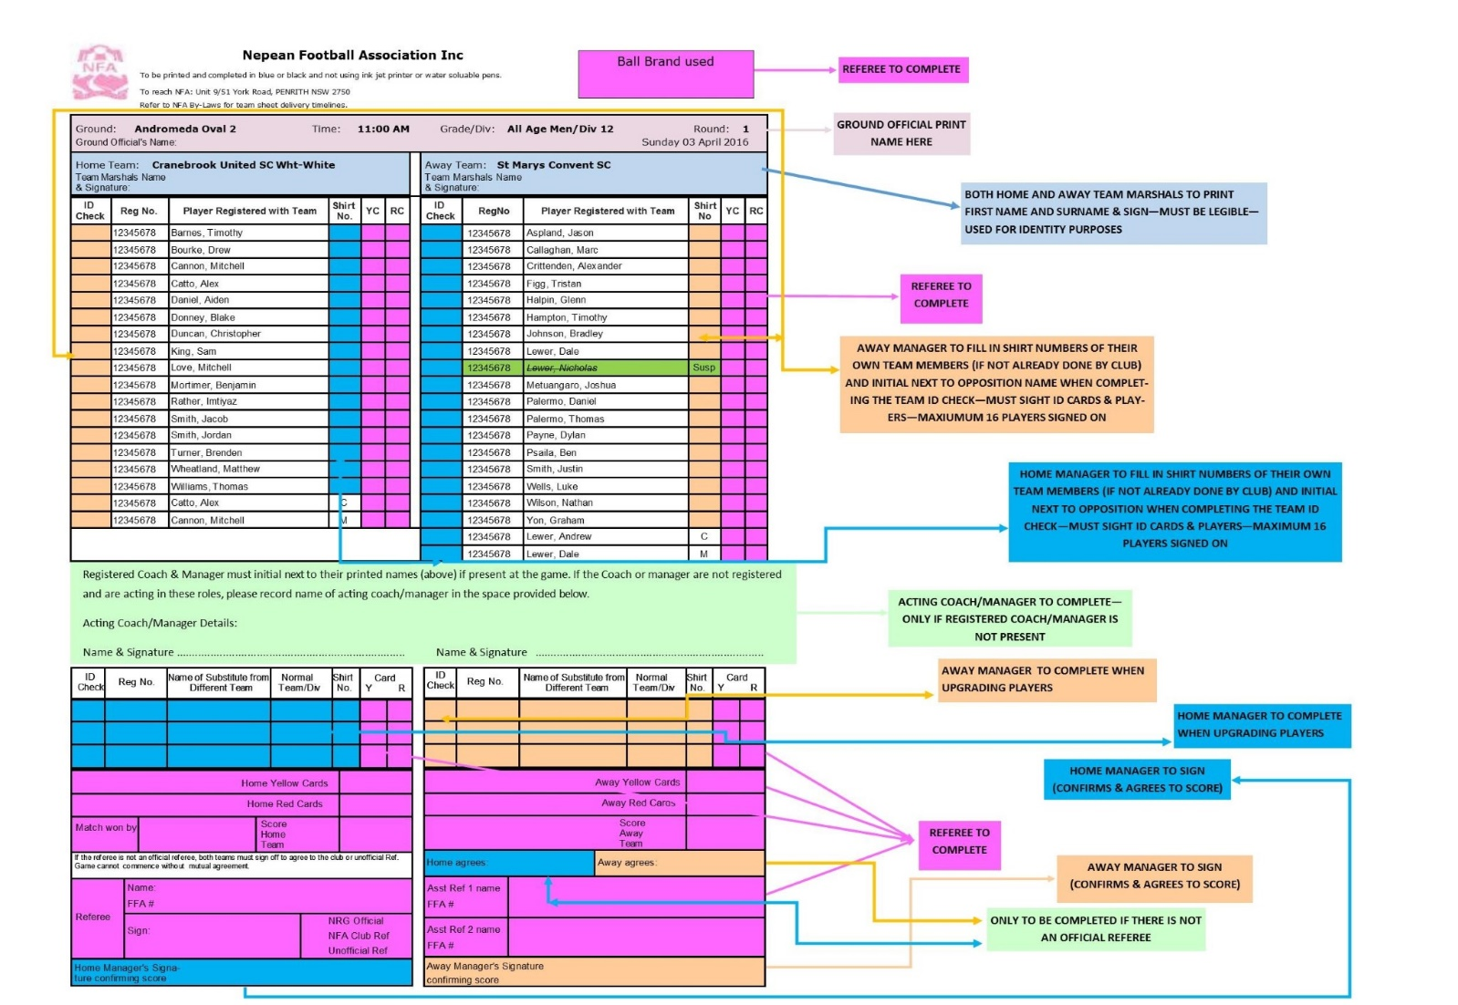
SAMPLE TEAM SHEET
2021

